Evidence Analysis Report
Digital Evidence Collection and Analysis Report
General Information
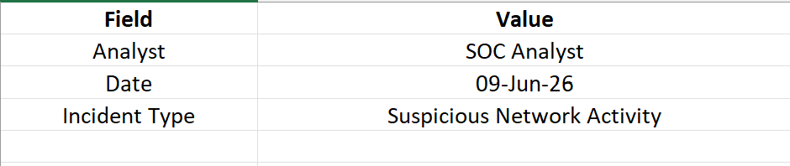
Executive Summary
This report documents the collection, preservation, and analysis of digital evidence associated with a suspected security incident. Evidence was gathered from a monitored workstation and analyzed using Velociraptor and FTK Imager. The objective was to identify suspicious network connections, preserve evidence integrity, and maintain a complete chain-of-custody throughout the investigation process.
Analysis revealed multiple outbound connections to an untrusted external IP address. The evidence was secured and documented according to standard digital forensic procedures.

Investigation Objective
The primary objectives of the investigation were:
- Collect relevant digital evidence.
- Preserve evidence integrity.
- Analyze network activity.
- Identify suspicious communications.
- Maintain proper chain-of-custody documentation.

Evidence Collection Process
The evidence collection process was performed as follows:
- Isolated the affected workstation.
- Collected system logs and network artifacts.
- Acquired forensic images using FTK Imager.
- Extracted network connection information using Velociraptor.
- Calculated hash values to verify evidence integrity.
- Stored evidence in a secure repository.

Tools Used
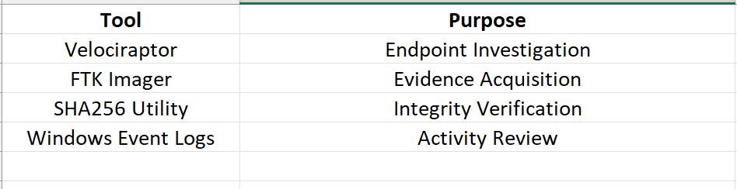
Network Connection Analysis
Velociraptor Query
SELECT * FROM netstat
Suspicious Connections Identified
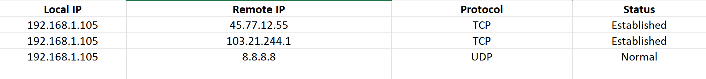Findings
- Repeated outbound communication was detected.
- One external IP address was not recognized as a trusted organizational resource.
- Connection behavior matched known command-and-control communication patterns.
- Further monitoring was recommended.

Evidence Analysis Findings
The network logs revealed outbound connections to suspicious external infrastructure. The activity occurred shortly after a file download event detected by the SOC monitoring system.
No signs of privilege escalation were observed. However, the communication pattern suggested possible malware beaconing behavior.
Risk Level: Medium

Chain of Custody Record
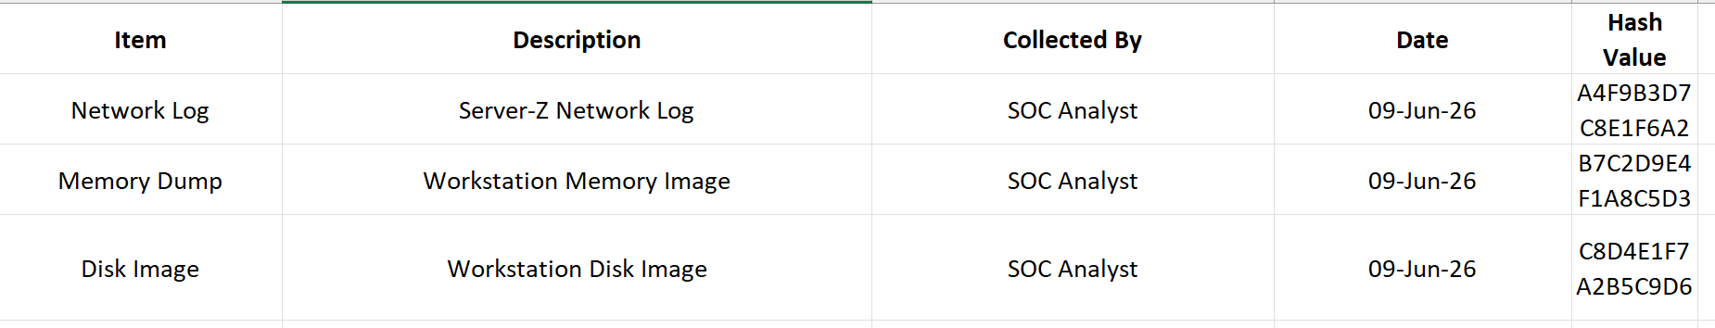
Evidence Integrity Verification
To ensure evidence integrity, SHA256 hash values were calculated immediately after acquisition and verified prior to analysis.
Verification Results
Evidence Item | Integrity Status
Network Log | Verified
Memory Dump | Verified
Disk Image | Verified
No alterations were detected during the investigation process.

Security Impact Assessment
Category | Assessment
Confidentiality | Low Impact
Integrity | Low Impact
Availability | No Impact
Overall Risk | Medium

Lessons Learned
- Early evidence collection improves investigation quality.
- Proper chain-of-custody documentation is essential.
- Network monitoring helps identify suspicious activity quickly.
- Hash verification protects evidence integrity.

Recommendations
- Continue monitoring suspicious external IP addresses.
- Strengthen endpoint protection policies.
- Improve network anomaly detection rules.
- Conduct periodic forensic readiness reviews.
- Enhance evidence storage and retention procedures.

Conclusion
The evidence analysis successfully identified suspicious outbound network communications and preserved relevant forensic artifacts. Evidence integrity was maintained through proper acquisition procedures and hash verification. The investigation demonstrated the importance of structured forensic analysis, chain-of-custody management, and continuous monitoring in supporting effective incident response operations.

